OBJECT DIAGRAMS

Student Subject
-name -subjectName
-id -marks

GradeCalculator
+calculateGrade()
1. (Relationship: Aggregation)

Customer Product
-name -productName
-id -quantity
-pricePerUnit

+generateBill()

Bill Generator

(2. Relationship : Composition)

SEQUENCE DIAGRAMS

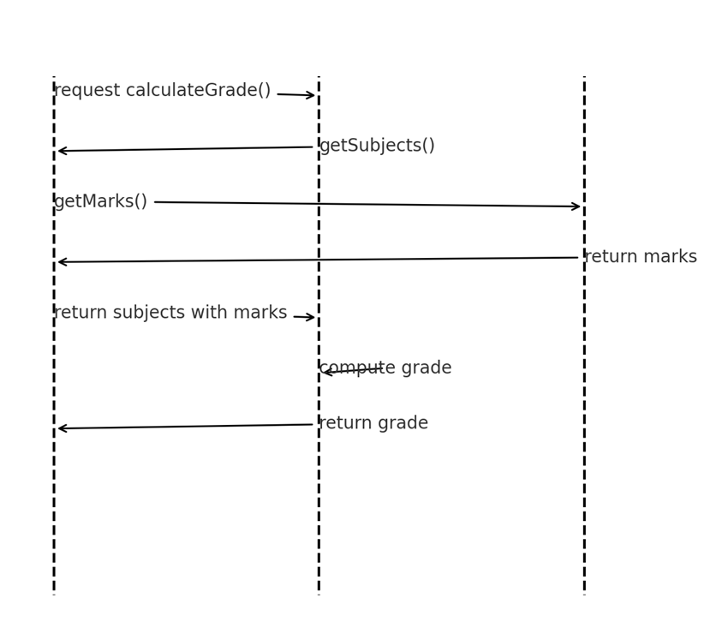
School Results Application

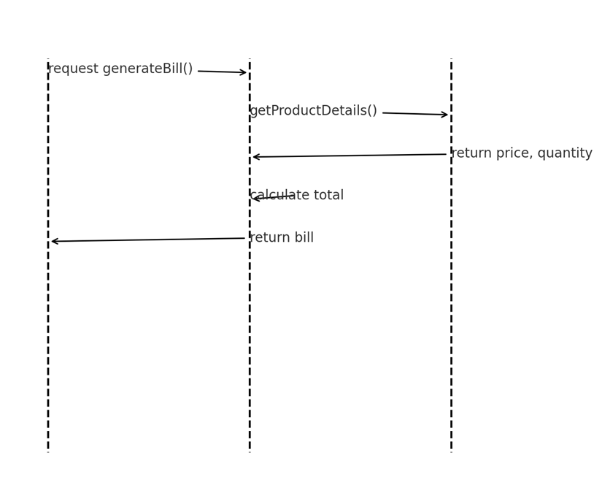
Grocery Store Bill Generation Application

